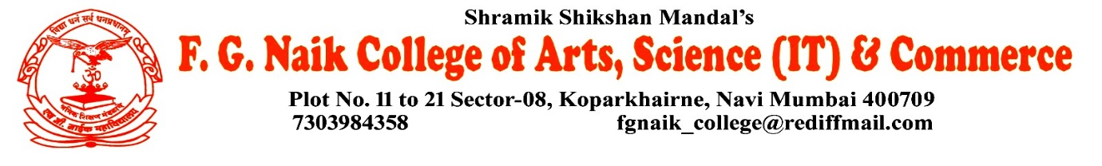

NSS UNIT
INDIAN CONSTITUTION DAY CELEBRATION
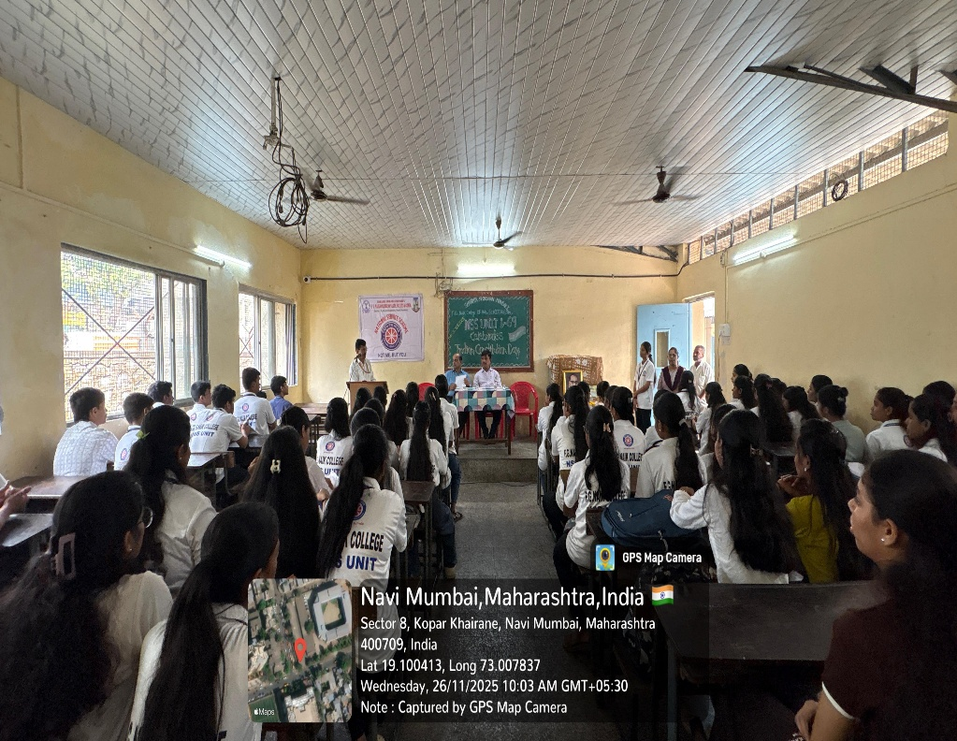
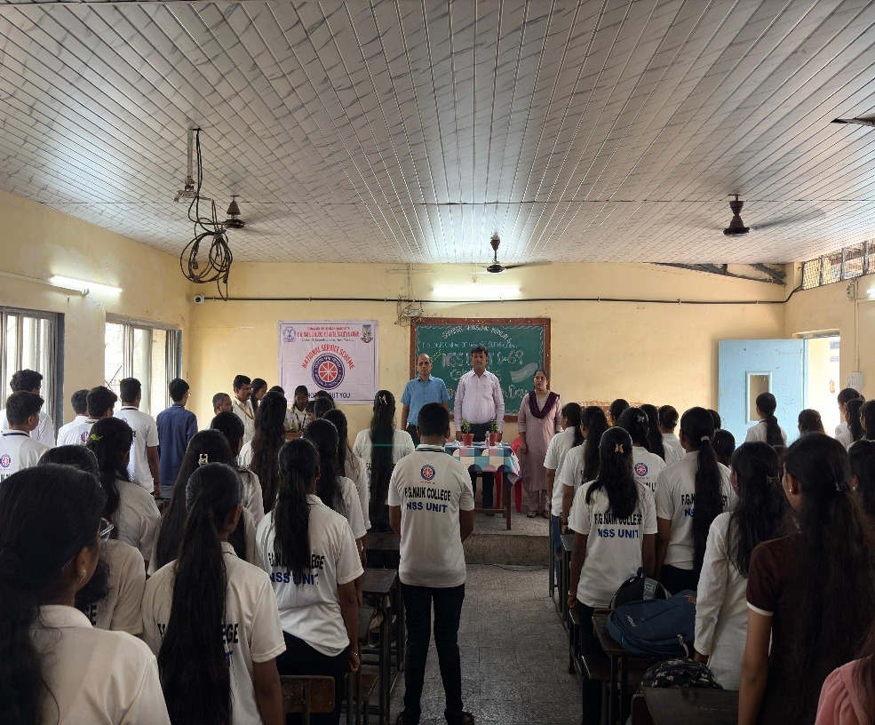

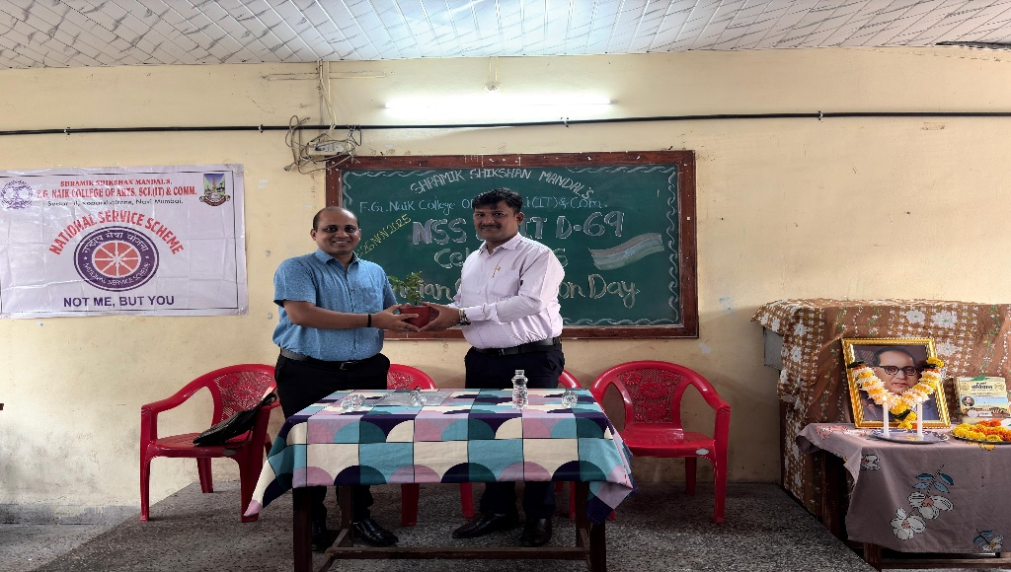
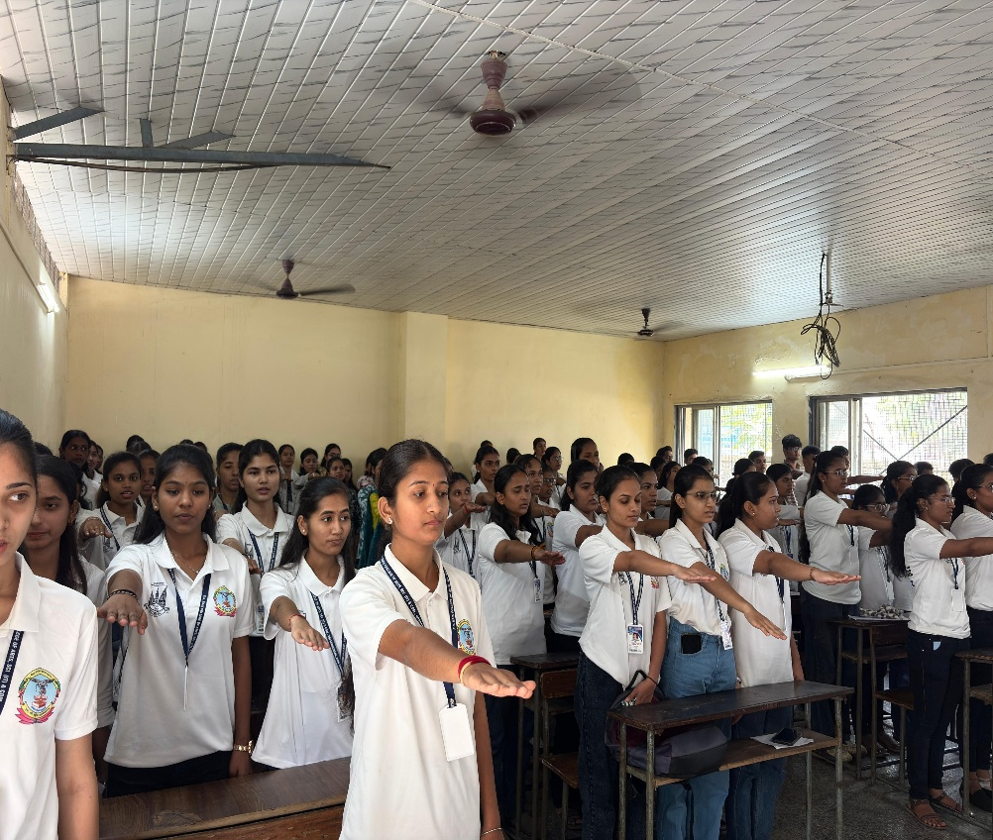

OBJECTIVE OF PROGRAM: To create awareness among students about the importance of the Indian Constitution and to promote constitutional values such as justice, liberty, equality, and fraternity.
DATE: 26/11/2025
LOCATION: F.G NAIK COLLEGE
PARTICIPATING STAFF: All the NSS volunteers, teaching and the non-teaching staff of the college.
NUMBER OF VOLUNTEERS PARTICIPATING: 127
The NSS Unit organized the Indian Constitution Day Celebration to commemorate the adoption of the Constitution of India and to educate students about its significance in shaping the nation. The program highlighted the fundamental rights, duties, and democratic principles enshrined in the Constitution.
Students actively participated in the celebration and gained a better understanding of constitutional values and their role as responsible citizens. The program helped in fostering respect for the Constitution and strengthening democratic awareness among students.
PROGRAM DETAILS: The program commenced with a formal welcome, creating a respectful and informative atmosphere.
The NSS Unit successfully conducted the Indian Constitution Day Celebration, emphasizing the importance of the Constitution in maintaining unity, democracy, and social justice in the country.

NSS IQAC
PROGRAM OFFICER CO-ORRDINATOR I/C PRINCIPAL

